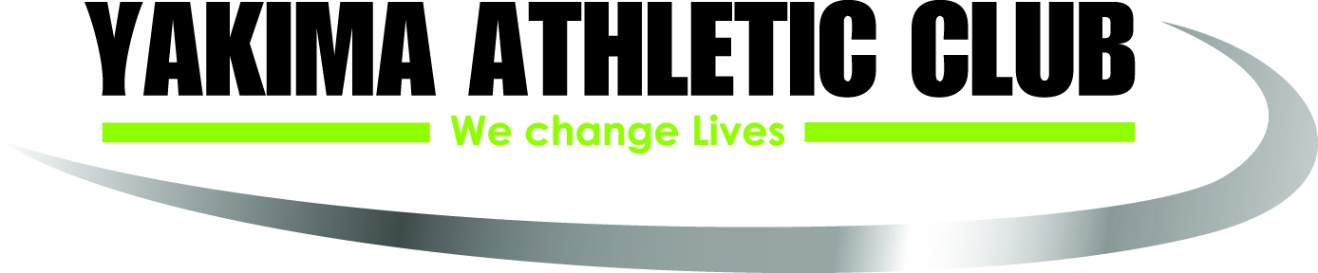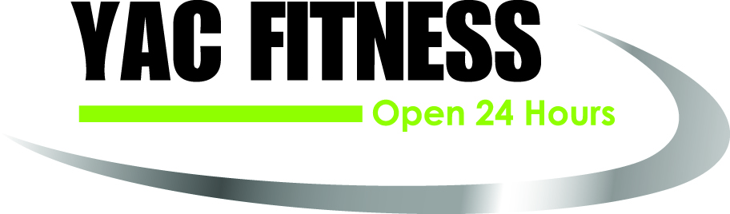

Application for Yakima Athletic Club/YAC Fitness Internship Program
Name:
Email:
Best number to reach you at:
Full Address:
City/State/Zip:
Date of Birth:
College:
Graduation Year:

Please take a moment to answer the following questions. Please type your answers and save them in a Word Document.
- Beyond the internship requirement for course completion, what motivates you to want to intern with our company?

- What are your goals after your internship?

- What motivates you to want to become a fitness professional.

- How can an internship with the Yakima Athletic Club and YAC Fitness elevate your position.

