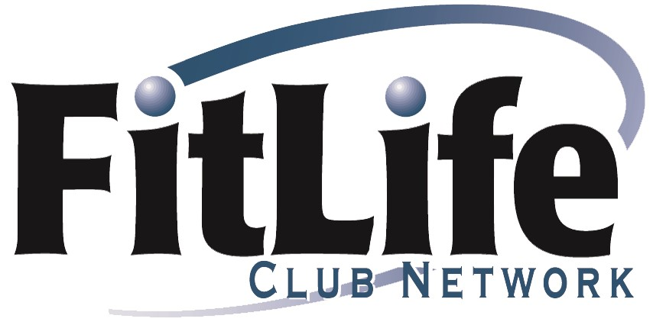

Club Directory 2022 www.fitlifeclubs.com
Idaho  Peak Health & Wellness - Coeur D'Alene  940 Ironwood Drive  Coeur d'Alene ID 83814  208 667 2582  Peak Health & Wellness - Hayden  190 West Centa Drive  Hayden ID 83835  208 762 9014  Peak Health & Wellness - Post Falls  927 E Polston Ave.  Post Falls ID 83854  208 773 0601  Rathdrum Fitness  14250 N. Thayer St.  Rathdrum ID 83858  208 687 5222  Montana  Capital City Health Club  1280 N. Montana  Helena MT 59601  406 442 6577  Peak Health & Wellness - Great Falls  1800 Benefis Ct  Great Falls MT 59405  406 727 7325  Peak Health & Wellness - Missoula  5000 Blue Mountain Rd  Missoula MT 59804  406 251 3344  Ridge Athletic Club  4181 Fallon Ave.  Bozeman MT 59718  406 589 1737  Oregon  Athletic Club of Bend*  61615 Athletic Club Dr  Bend OR 97702  541 385 3062  Burn Fitness  1755 Mt Hood Avenue Suite 130  Woodburn, OR 97071  503 980 9050  Cascade Athletic Club - Gresham  19201 SE Division St.  Gresham OR 97030  503 665 4142  Cascade Athletic Club - 205  9260 SE Stark St  Portland OR 97216  503 257 4142  Courthouse Athletic Club - Battle Creek  6250 Commercial St SE  Salem OR 97306  503 588 2582 opt.3  Courthouse Athletic Club - Keizer  117 McNary Estates Drive  Keizer OR 97303  503 588 2582 opt.5  Courthouse Athletic Club - Lancaster  4132 Devonshire N  Salem OR 97301  503 588 2582 opt.7 | Courthouse Athletic Club - South River Rd  2975 River Road S  Salem OR 97302  503 588 2582 opt.6  Courthouse Athletic Club - West Salem  300 Glen Creek Rd NW  Salem OR 97304  503 588 2582 opt.4  Downtown Athletic Club  999 Willamette  Eugene OR 97401  541 484 4011  East Side Athletic Club - Clackamas  9100 SE Sunnyside Rd.  Clackamas OR 97015  503 659 3846  East Side Athletic Club - Milwaukie  4606 SE Boardman Ave.  Milwaukie OR 97267  503 659 3845  Eugene Swim & Tennis Club  2766 Crescent Ave  Eugene OR 97408  541 342 4414  Hood River Athletic Club  1330 Brookside Dr  Hood River OR 97031  541 386 3230  The Dalles Athletic Club  731 Pomona W  The Dalles OR 97058  541 298 8508  Grande Ronde Fitness Club  2214 Adams Ave  La Grande OR 97850  541 963 2582  Harbor Isles Tennis & Fitness Club  2805 Front St.  Klamath Falls OR 97601  541 884 3300  Hawthorn Farm Athletic Club  4800 NE Belknapp Ct  Hillsboro OR 97124  503 640 6404  Multnomah Athletic Club  1849 SW Salmon St.  Portland, OR 97205  503 223 6251  Monmouth Fitness Club  165 E. Main Street  Monmouth, OR 97361  503-838-2951  Mt. Hood Athletic Club  37095 Highway 26  Sandy OR 97055  503 826 0565  Mt. Park Racquet Club  3 SW Botticelli  Lake Oswego OR 97035  503 635 3776  NW Women’s Fitness Club  2714 NE Broadway  Portland, OR. 97232  503-287-0655 | Pacific Athletic Club  320 1st St.  Columbia OR 97018  503 397 1000  Roundup Athletic Club  1415 Southgate  Pendleton OR 97801  541 276 0880  Sisters Athletic Club*  1001 E. Desperado Trail  Sisters OR 97759  541 549 6878  Stafford Hills Club  5916 SW Nyberg Ln  Tualatin OR 97062  503-612-2400  Sunset Athletic Club  13939 NW Cornell Rd  Portland OR 97229  503 645 3535  Timberhill Athletic Club  2855 NW 29th St  Corvallis OR 97330  541 757 8559  West Coast Fitness - St. Johns  7522 N. Lombard  Portland OR 97203  503 283 5404  West Hills Racquet & Fitness Club  2200 SW Cedar Hills Blvd  Portland OR 97225  503 646 4106  Washington  425 Fitness Issaquah  1025 NW Gilman Blvd  Issaquah, WA 98027  425 369 8585  425 Fitness Bothell  18524 Bothell Everett Highway  Bothell, WA 98012  425 486 2805  425 Fitness Redmond  7956 178th Place NE  Redmond, WA 98052  425 883 9494  All Pride Fitness  3307 Evergreen Way, #701  Washougal WA 98671  360 835 1713  Bellingham Athletic Club - Cordata  4191 Meridian St  Bellingham WA 98226  360 676 1800  Cascade Athletic Club - Fisher's Landing  16096 SE 15th St  Vancouver WA 98683  360 597 1100  CBRC Health and Wellness Clinic  1776 Terminal Dr  Richland WA 99354  509 943 8416  Harbor Square Athletic Club  160 W Dayton St  Edmonds WA 98020  425 778 3546 | Island Athletic Club  5522 S Freeland Ave  Freeland WA 98249  360 331 2582  Lake Shore Athletic Club  2401 NW 94th St.  Vancouver WA 98664  360 574 1991  LifeQuest Fitness Center  4215 Convention Place  Pasco WA 99301  509 545 5191  Olympic Athletic Club*  5301 Leary Ave NW  Seattle WA 98201  206 789 5010  Pacific Clinic/Tri-City Court Club  1350 N Grant St  Kennewick WA 99336  509 783 5465  Stillaguamish Athletic Club  4417 172nd St NE  Arlington WA 98223  360 435 9404  Suncrest Fitness Center  6066 Highway 291  Nine Mile Falls WA 99026  509 465 0131  Wenatchee Racquet & Athletic Club  1913 Skyline Dr  Wenatchee WA 98801  509 662 3544  WORX of Wenatchee  12 N. Worthen  Wenatchee WA 98807  509 663 4965  WORX of East Wenatchee  291 Ninth Street  East Wenatchee WA 98802  509 884 4965  Yakima Athletic Club  2501 Racquet Lane  Yakima WA 98902  509 453 6521  *May charge a nominal fee

